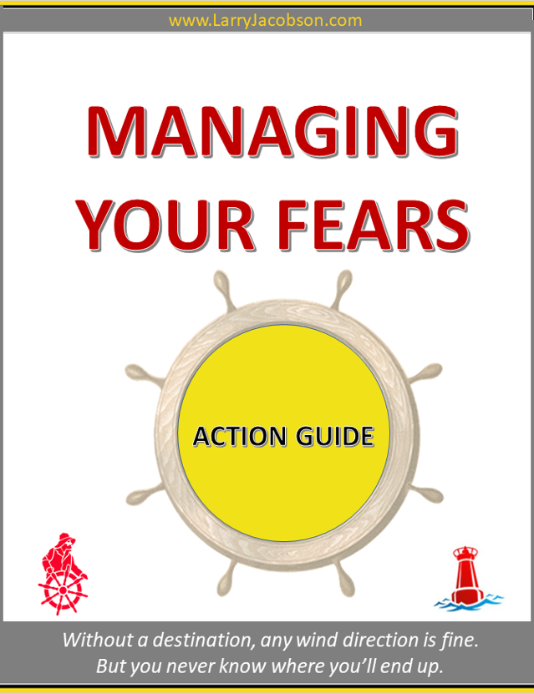

Managing
Your Fears
*** Please answer the questions below, then print this sheet and keep in your 3-Ring Binder. Use a Clear-Cover
View Binder, and insert the course cover in the front cover pocket – Click Here to print out your cover!

Action Guide 6.1 and 6.2

* Excerpt from the Sail into Retirement, Life-Style Planning program – read complete details about the program here: sir.SailIntoRetirement.com (hold the Ctrl key on your keyboard, then click on the link; or just copy and paste it into your browser)

Part 1 - Action Guide 6.1
In this exercise, you’re going to identify one of your biggest fears about moving forward with your goals and vision. After examining it closely, you’ll see the fear truly is nothing but False Expectations Appearing Real.
You can follow this same exercise for as many fears as you like. The important part here is to learn and apply the process.

Let’s Set Sail!
1. First write down that big fear weighing on you?
Type your answer here – use as much space as you need…

2. Now examine the fear closely and identify three elements that cause
you to feel this fear?
Type your answer here – use as much space as you need…

3. Next, what are the pragmatic counter-arguments to the three elements
above? What are the logical explanations why these elements aren’t as
valid as your initial logic?
Type your answer here – use as much space as you need…

4. Identify how these fears help you.
For example, if you’re planning a long canoe trip and are “afraid of drowning” – this
is helpful, as now you’ll buy a good life-vest. Or, if you’re “afraid of not being strong
enough” for the trip – that’s okay! Get your physical checkup, then join a gym to get
stronger, so you’ll feel confident and ready.
Type your answer here – use as much space as you need…

5. What will you tell yourself and how will you act the next time this fear
raises its ugly head?
Type your answer here – use as much space as you need…

Part 2 - Action Guide 6.2
1. What is one fear you are expecting to face when it comes to planning your retirement lifestyle, that you may not have thought of yet? By identifying it now, you won’t be surprised when it shows up!
Type your answer here – use as much space as you need…

2. You can follow this same exercise for as many expected fears as you like. The important part here is to learn the process. List some other fears you can expect.
Type your answer here – use as much space as you need…

3. Additionally, to make your vision a reality and achieve the goals in
your plan. You’ll need to overcome the fear of leaving the old and
the familiar. What is it you’re afraid of leaving behind?
Type your answer here – use as much space as you need…

4. Have the confidence that you will rise above the fear of what the new might bring about. Beginning something new, and not yet being familiar with it, can be scary. Jot down something which is going to be part of your plan - something you don’t’ know how to do yet. Remember, the joy is in the journey and the learning.
Type your answer here – use as much space as you need…

5. You’re going to be making a new plan - one you’ve never written before and this can be scary. Are you afraid of writing this plan? Why? You’ve written plans before and you can write this one too.
Type your answer here – use as much space as you need…

6. Without action, a plan is just a piece of paper. Once you begin taking action, the rest will follow. Can you easily identify the first step in your plan, when will you take that first step?
Type your answer here – use as much space as you need…

Well Done!
You have completed Lesson 6.2 Planning Action Sheet!
Closing Message
Now that you completed this lesson, are you starting to view fear from a new angle?
Let’s look at the scariest moment in your life – what was it? I bet you remembered that moment instantly.
When you look back at it now, do you see how you could have used fear to your advantage? Remember the two steps involved in using fear to your advantage.
1. Recognize that you are afraid

2. Accept and embrace your fears
Once you have accepted and embraced your fears, use the power they give you. You now know that fear is nature’s way of making you focus on the task at hand. It sharpens your senses and makes you more alert. And you can use that fear to your advantage at the very moment it rears its little red devil head.
Now that you identified your fears about each action step that takes you closer to your vision, and you addressed each of those individual fears with logical answers, you’ll find you can transform your fears into great strength.
Learn to use your fears to your advantage. Don’t forget what Emerson said: Fear or not, “Once you make a decision, the universe conspires to make it happen.”
Move forward welcoming and embracing your fears.
All right, in this lesson we dealt with some fearsome issues, and you are probably ready for something lighter.
In Lesson Seven, we’re going to have some fun.
If you’re feeling blue, or depressed; or having issues keeping a positive attitude about retirement,
then this is your lesson. You won’t be singing the blues anymore - plan to enjoy a whole new way of looking at events and circumstances.
I’ll see you in Lesson Seven!
* Visit www.Sir.SailIntoRetirement.com to enroll in the complete program

Sincerely,
Larry Jacobson
Your Sail into Retirement Navigator
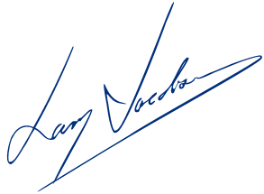
www.LarryJacobson.com

